RIVER VALLEY HIGH SCHOOL
General Certificate of Education Advanced Level
Preliminary Examination 2026
Higher 2
H

GEOGRAPHY 9173/02
Paper 2 17 September 2026
INSERT 3 hours

READ THESE INSTRUCTIONS FIRST

This Insert contains all the Resources referred to in the questions.

___________________________________________________________________
This document consists of 6 printed pages.

[Turn over

Resource 1 for Question 1
Location of City Square Mall and its environs

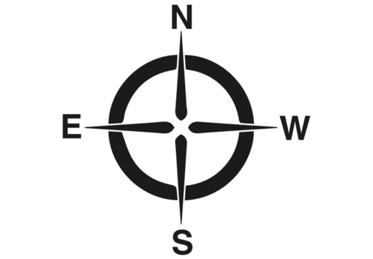
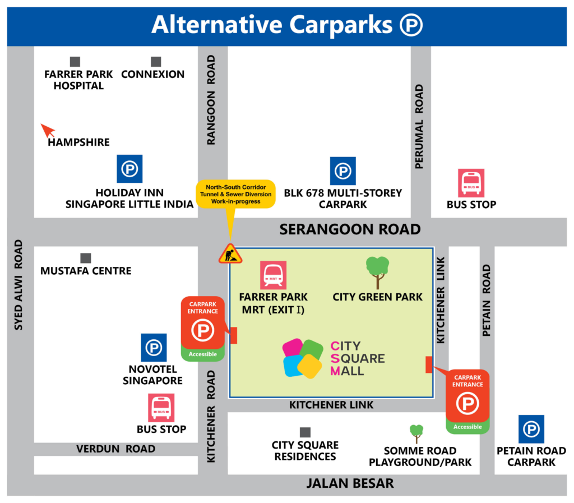

Scale: 1 cm to 64 m

Resource 2A for Question 1
City Square Mall and City Green in front of it

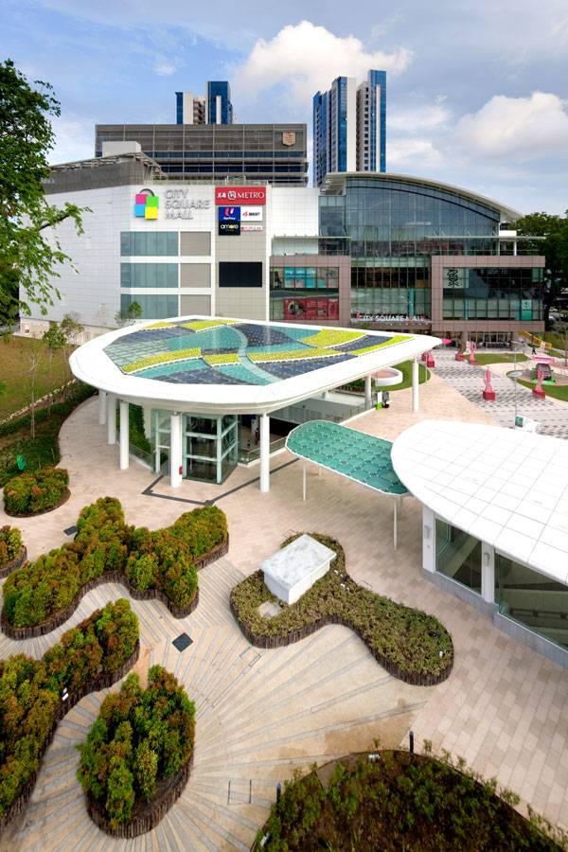
Green Roof: Reduces temperature, harnesses solar energy, allows natural lighting, collects rainwater and promotes cross ventilation.

Resource 2B for Question 1
An example of a sustainability-themed wall mural in the mall

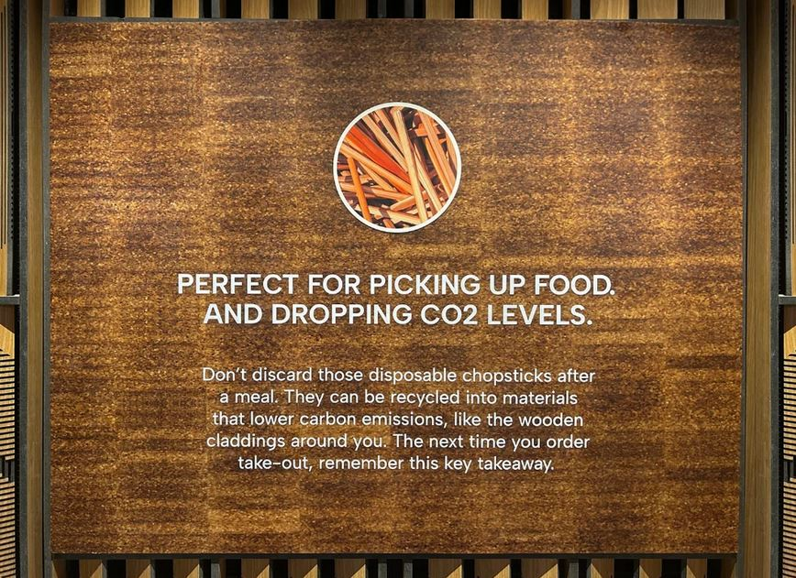
Resource 3 for Question 1
Questionnaire survey used by the students in their investigation
Survey on the effectiveness of features of City Square Mall in
Resource Conservation

Hello! We are a group of students from XYZ Junior College. We are conducting a survey to find out residents’ opinions of the effectiveness of City Square Mall’s features in resource conservation, and your honest opinions will be greatly appreciated. Please be assured that all information collected will be used solely for research purposes, and no personal information will be divulged.

Age:

Gender: M/F

Race: C/M/I/O

Annual Income: __________________________

- How often do you visit City Square Mall?

- Are you aware of the features at the mall that promote resource conservation? Y/N

- How effective are the following features in the mall in resource conservation?
(1: Very ineffective; 4: Very effective)

(a) Escalators and travelators with auto-lighting and slow-down | 1 | 2 | 3 | 4
(b) Sensors that ensure landscaped greenery is not watered on rainy days | 1 | 2 | 3 | 4
(c) Highly efficient air-conditioners which recycle condensate water | 1 | 2 | 3 | 4
(d) Mall roof with sensors to regulate lighting and allows natural lighting | 1 | 2 | 3 | 4
(e) Sustainability-themed wall murals with eco-messages | 1 | 2 | 3 | 4
(f) LED lighting for mall facade | 1 | 2 | 3 | 4
(g) Green Roof at City Green | 1 | 2 | 3 | 4

- Explain your choices to Question 3.
____________________________________________________________________________________________________________________________________________

- Are there other similar features you would like to see being introduced in the mall? Please elaborate.
______________________________________________________________________________________________________________________________

Thank you for your time and cooperation!

Resource 4 for Question 1
Responses to Question 3 in the questionnaire survey

Feature | Option
Feature | 1 | 2 | 3 | 4
(a) Escalators and travelators | 14 | 21 | 37 | 48
(b) Sensors | 10 | 29 | 42 | 39
(c) Air-conditioners | 29 | 12 | 63 | 16
(d) Mall roof | 12 | 25 | 55 | 28
(e) Wall murals | 67 | 44 | 6 | 3
(f) LED lighting | 17 | 35 | 48 | 20
- Green Roof | 28 | 51 | 23 | 18

Resource 5 for Question 2
Share of energy from fossil fuels, 1965 to 2021, for selected countries
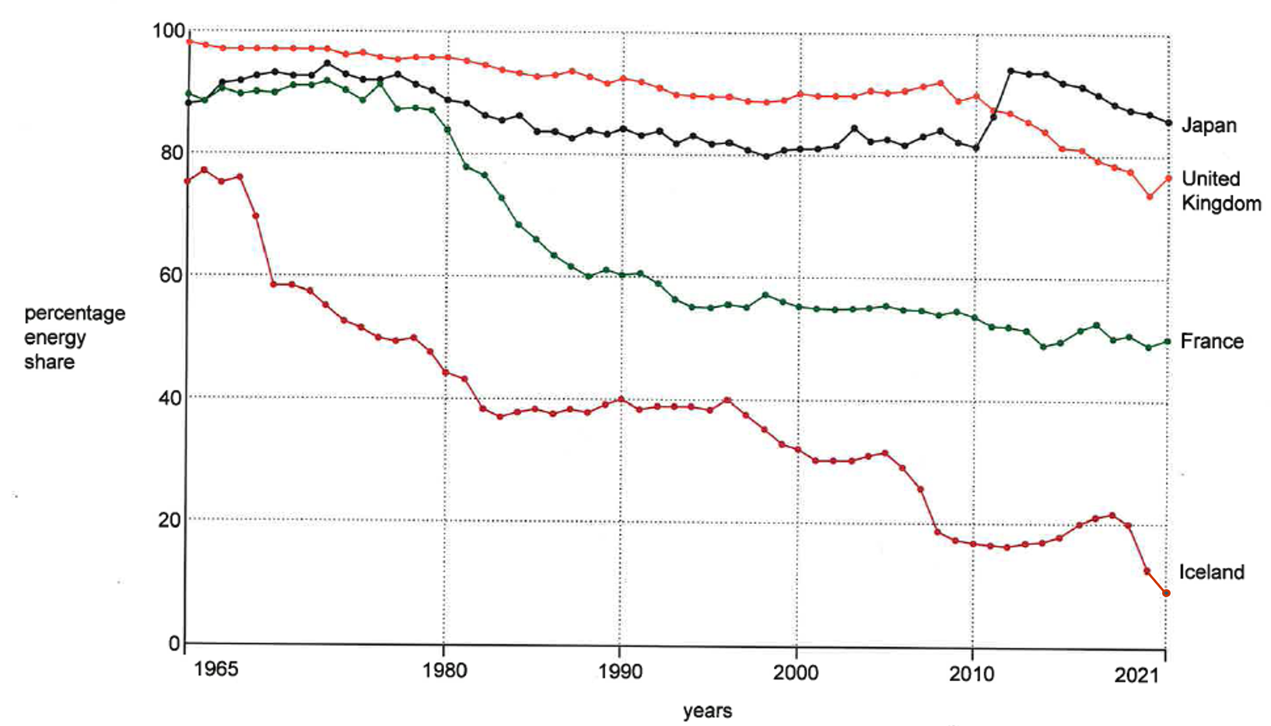

Resource 6 for Question 2
Projected impacts of contemporary climate change on global plant species richness, projected by 2050
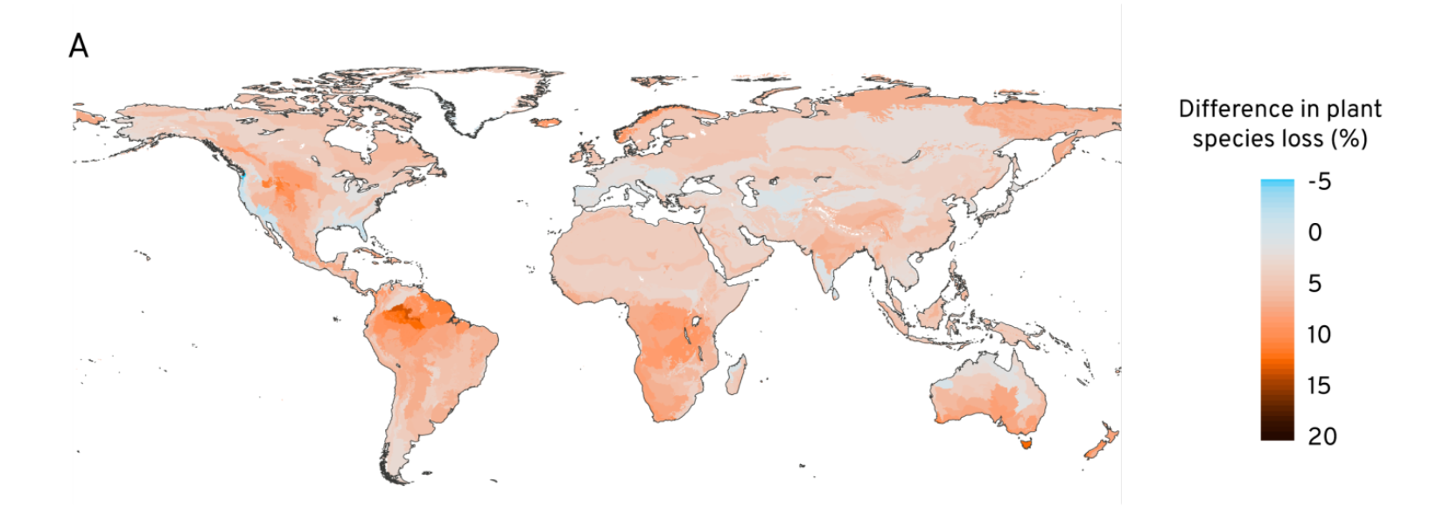

Resource 7 for Question 2
Trends in global climate finance for adaptation, mitigation and cross-cutting activities (2013–2019)
